Test Plan Document – CBOEdirect 4.9

Hybrid Automated Liaison (HAL)

Block-Publishing of Product State Events

PDPM+

Christopher Hield
Vivek Vaishampayan

Contents

Hybrid Automated Liaison (HAL)

HAL Test Trading Property Setup……………………………………………………….3

Setup BOTR on SBT………………………………………………………………………6
Setup NBBO on TPF ………………………………………………………………………6
HAL Test Cases……………………………………………………………………………9

Block-Publishing of Product State Events

Block-Publishing Test Cases………………………………………………….…….……58

PDPM+

PDPM+ Test Cases……………………………………………………………….………59
Hybrid Automated Liaison (HAL) Test Cases

HAL Test Trading Property Setup

- AuctionOrderTicksAwayFromNBBO : Auction Type 4 (HAL), Value: 1

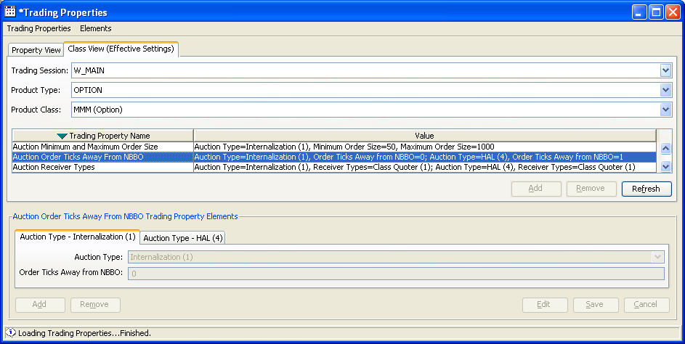

- AllowedHALTypes: “1,2,3"

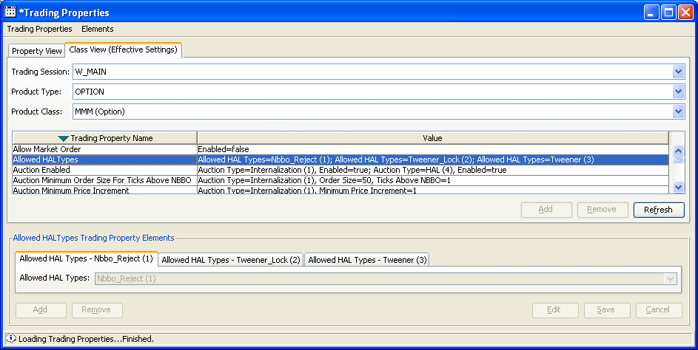

- HALTriggerTimer: 90000

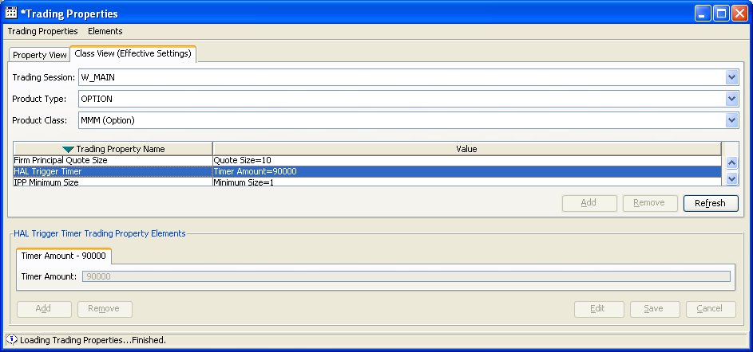

- AuctionTimeToLive: Auction Type 4 (HAL), Min. Value: 90000, Max. Value: 90000

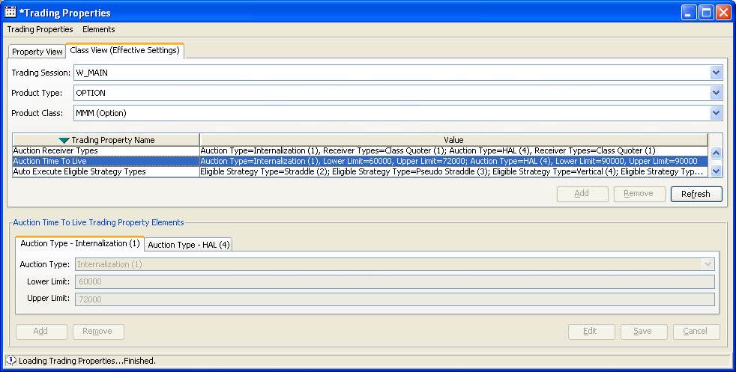

- AuctionEnabled: Auction Type 4 (HAL), Value: true

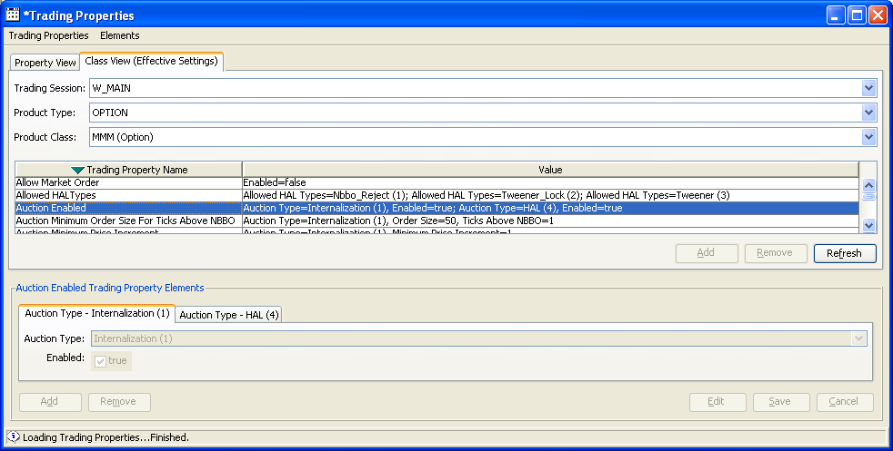

- AuctionMinQuoters: Auction Type 4 (HAL), Value: 1

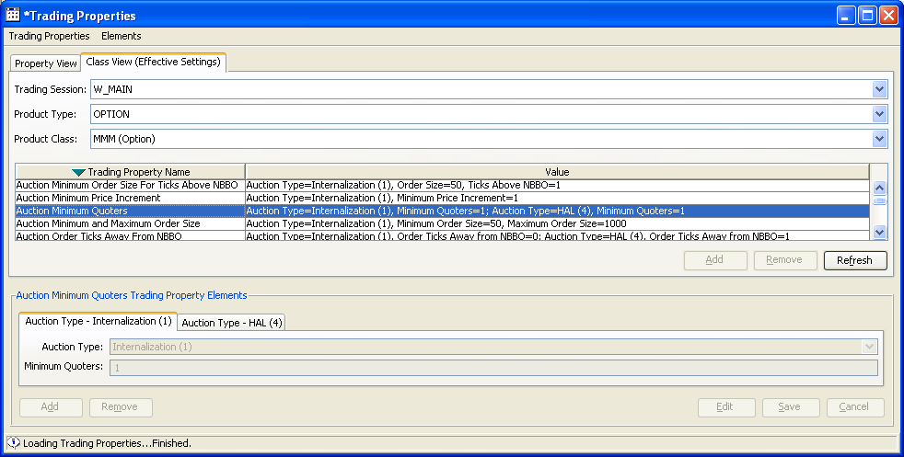

- AuctionReceiverTypes: Auction Type 4 (HAL), Value: 1

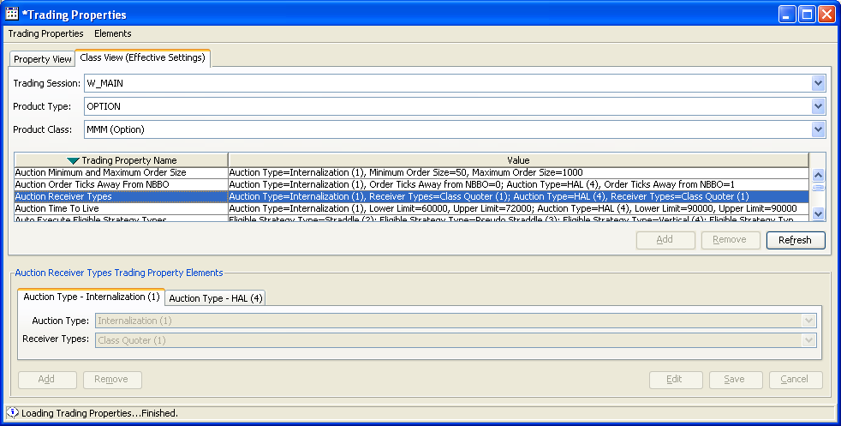

Setup BOTR on SBT
To set the BOTR on SBT to match test case needs, do the following:

- Log onto the SBT “BC” box for the Class that you are using (i.e., A-P classes on atgqabc1, Q-Z classes on atgqabc2).

- Whenever you need to change the SBT BOTR, from the “BC” box “run_dir”, run the script “../setBOTR” passing it the following command line parameters:

../setBOTR Classkey BidPrice AskPrice Quantity

../setBOTR 133300412 1.00 1.20 100

Setup NBBO on TPF

ATG Staff will need to set up an SLD script to set the NBBO for 3 different series in your test class.

Required NBBO Series 1: 10 @ 1.00 10 @ 1.20
Required NBBO Series 2: 50 @ 1.00 50 @ 1.20
Required NBBO Series 3: 100 @ 1.00 100 @ 1.20

When executing a test that needs a starting NBBO of [10 @ 1.00 - 10 @ 1.20], then use “Series 1”. When the starting NBBO is [50 @ 1.00 - 50 @ 1.20], then use “Series 2”. When the starting NBBO is [100 @ 1.00 - 100 @ 1.20], then use “Series 3”.

HAL Test Cases

- Opposite Side Non-Contingent (Non-HAL Enabled) 'C' Order arrives during NBBO Reject flash
- Opposite Side Non-Contingent (Non-HAL Enabled) 'C' Order arrives during Tweener-Lock flash
- Opposite Side Non-Contingent (Non-HAL Enabled) 'C' Order arrives during Tweener flash
- Same Side Non-Contingent (Non-HAL Enabled) 'C' Order arrives during NBBO Reject flash
- Same Side Non-Contingent (Non-HAL Enabled) 'C' Order arrives during Tweener-Lock flash
- Same Side Non-Contingent (Non-HAL Enabled) 'C' Order arrives during Tweener flash
- Opposite Side Quote arrives during NBBO Reject flash
- Opposite Side Quote arrives during Tweener-Lock flash
- Opposite Side Quote arrives during Tweener flash
- Same Side Quote arrives during NBBO Reject flash
- Same Side Quote arrives during Tweener-Lock flash
- Same Side Quote arrives during Tweener flash
- Same Side Quote Update arrives during NBBO Reject flash
- Same Side Quote Update arrives during Tweener-Lock flash
- Same Side Quote Update arrives during Tweener flash
- Opposite Side 'I' Order arrives during NBBO Reject flash
- Opposite Side 'I' Order arrives during Tweener flash
- Opposite Side 'I' Order arrives during Tweener-Lock flash
- Same Side 'I' Order arrives during NBBO Reject flash
- Same Side 'I' Order arrives during Tweener flash
- Same Side 'I' Order arrives during Tweener-Lock flash
- Opposite Side Non-Contingent (HAL Enabled) ‘C’ Order arrives during NBBO Reject flash.
- Opposite Side Non-Contingent (HAL Enabled) ‘C’ Order arrives during Tweener-Lock flash.
- Opposite Side Non-Contingent (HAL Enabled) ‘C’ Order arrives during Tweener flash.
- Opposite Side RFP Response arrives during NBBO Reject flash
- Opposite Side RFP Response arrives during Tweener-Lock flash
- Opposite Side RFP Response arrives during Tweener flash
- Same Side Non-Contingent (HAL Enabled) ‘C’ Order arrives during NBBO Reject flash.
- Same Side Non-Contingent (HAL Enabled) ‘C’ Order arrives during Tweener-Lock flash.
- Same Side Non-Contingent (HAL Enabled) ‘C’ Order arrives during Tweener flash.
- Opposite Side Contingent C-Order with HAL arrives during Contingent [None/AON] NBBO Reject
- Opposite Side Contingent C-Order with HAL arrives during Contingent [AON/FOK] NBBO Reject
- Opposite Side Contingent C-Order with HAL arrives during Contingent [STP/STP-LMT] NBBO Reject
- Opposite Side I-Order arrives during Contingent (AON/FOK/IOC/STP/STP-LMT) NBBO Reject/Tweener-Lock/Tweener-Lock flash
- No Response arrives during Contingent (AON/FOK/IOC/STP/STP-LMT) NBBO Reject/Tweener-Lock/Tweener-Lock flash
- Cancel a HAL’d Order During NBBO Reject HAL Auction (No Responses)
- Cancel an RFP to a HAL Auction
- Cancel/RE a HAL’d Order During NBBO Reject HAL Auction (No Responses)
- Non-Trade/Ship HAL Auction Test (‘M’ Auction)

Block-Publishing of Product State Events

- Block-Publishing Test One
- Block-Publishing Test Two

PDPM+Test Plan

- Test1 – Allocation Test
- Test2 – Allocation Test (Change USER1 Quote to $0.0 - $1.30 0X100)
- Test3 – Allocation Test (Add 2 Users)

- Opposite Side Non-Contingent (Non-HAL Enabled) 'C' Order arrives during NBBO Reject flash

  - Test Case 1.1:

    - Action: Set BOTR: 1.00 x 10 – 1.20 x 10

    - Action: Set CBOE: 1.00 x 10 – 1.30 x 10 (MM1 Quote)

    - Action: Enter Order: ‘C’ Origin, ‘H’ Enabled, Buy 50 @ 1.40 (BD1 Order)

      - Result: HAL Flashes at: 50 @ 1.20

    - Action: Change BOTR Market: BOTR changed to 1.10 – 1.25 (Worse than Flash Price)

      - Result: CBOE Still Not NBBO
      - Result: Flash Continues

    - Action: Enter Incoming Order: ‘C’ Origin, Not ‘H’ Enabled, Sell 25 @ 1.25 (MM2 Order)

      - Result: Trade 25 @ 1.25
        - BD1 Fill: Buy 25 @ 1.25
        - MM2 Fill : Sell 25 @ 1.25

      - Result: HAL Auction continues for remaining 25 Qty

      - Result: HAL Auction Expires after N seconds

      - Result: Trade 10 @ 1.30,
        - BD1 Fill: Buy 10 @ 1.30
        - MM1 Fill : Sell 10 @ 1.30

      - Result: Ship remaining HAL’d Order (Buy 15 @ 1.40) to TPF
(Reason Code: 5503 FLASH_WITH_TRADE_AND_SHIP)

  - Test Case 1.2:

    - Action: Set BOTR: 1.00 x 10 – 1.20 x 10

    - Action: Set CBOE: 1.00 x 10 – 1.30 x 10 (MM1 Quote)

    - Action: Enter Order: ‘C’ Origin, ‘H’ Enabled, Buy 50 @ 1.40 (BD1 Order)

      - Result: HAL Flashes at: 50 @ 1.20

    - Action: Change BOTR Market: BOTR changed to 1.30 – 1.40

      - Result: CBOE Is NBBO
      - Result: Flash Continues

    - Action: Enter Incoming Order: ‘C’ Origin, Not ‘H’ Enabled, Sell 25 @ 1.15 (MM2 Order)

      - Result: HAL Auction Ends

      - Result: Trade 25 @ 1.30
        - BD1 Fill: Buy 25 @ 1.30
        - MM2 Fill: Sell 25 @ 1.30

      - Result: Trade 10 @ 1.30,
        - BD1 Fill: Buy 10 @ 1.30
        - MM1 Fill : Sell 10 @ 1.30

      - Result: Ship remaining HAL’d Order (Buy 15 @ 1.40) to TPF
(Reason Code: 5502 FLASH_NO_TRADE_AND_SHIP)

- Opposite Side Non-Contingent (Non-HAL Enabled) 'C' Order arrives during Tweener-Lock flash

Test Case 2.1

Action: Set BOTR: 1.00 x 10 – 1.20 x 10

Action: Set CBOE: 1.00 x 10 – 1.30 x 10 (MM1 Quote)

Action: Enter Order: ‘C’ Origin, ‘H’ Enabled, Buy 50 @ 1.25 (BD1 Order)

Result: HAL Flashes at: 50 @ 1.20

BOTR Not Changed

Action: Enter Incoming Order: ‘C’ Origin, Not ‘H’ Enabled, Sell 25 @ 1.10 (MM2 Order)

Result: Trade 25 @ 1.20

BD1 Fill: Buy 25 @ 1.20

MM2 Fill: Sell 25 @ 1.20

Result: HAL Auction continues for remaining 25 Qty

Result: HAL Auction Expires after N seconds

Result: Ship remaining HAL’d Order (Buy 25 @ 1.25) to TPF
(Reason Code: 5502 FLASH_NO_TRADE_AND_SHIP)

Test Case 2.2

Action: Set BOTR: 1.00 x 10 – 1.20 x 10

Action: Set CBOE: 1.00 x 10 – 1.30 x 10 (MM1 Quote)

Action: Enter Order: ‘C’ Origin, ‘H’ Enabled, Buy 50 @ 1.25 (BD1 Order)

Result: HAL Flashes at: 50 @ 1.20

Action: Change BOTR Market: BOTR changed to 1.25 – 1.40 (CBOE is NBBO)

Action: Enter Incoming Order: ‘C’ Origin, Not ‘H’ Enabled, Sell 25 @ 1.00 (MM2 Order)

Result: Trade 25 @ 1.25

BD1 Fill: Buy 25 @ 1.25

MM2 Fill: Sell 25 @ 1.25)

Result: HAL Auction continues for remaining 25 Qty

Result: HAL Auction Expires after N seconds

Result: Book remaining HAL’d Order (Buy 25 @ 1.25)

- Opposite Side Non-Contingent (Non-HAL Enabled) 'C' Order arrives during Tweener flash

Test Case 3.1

Action: Set BOTR: 1.00 x 10 – 1.20 x 10

Action: Set CBOE: 1.00 x 10 – 1.30 x 10 (MM1 Quote)

Action: Enter Order: ‘C’ Origin, ‘H’ Enabled, Buy 50 @ 1.10 (BD1 Order)

Result: HAL Flashes at: 50 @ 1.10

Action: Change BOTR Market: BOTR changed to 1.00 – 1.05 (Better than Flash Price)

Action: Enter Incoming Order: ‘C’ Origin, Not ‘H’ Enabled, Sell 25 @ 1.20 (MM2 Order)

Result: HAL Auction Ends

Result: Ship entire HAL’d Order (Buy 50 @ 1.25) to TPF
(Reason Code: 5502 FLASH_NO_TRADE_AND_SHIP)

Result: Book new incoming order (Sell 25 @ 1.20)

Test Case 3.2

Action: Set BOTR: 1.00 x 10 – 1.20 x 10

Action: Set CBOE: 1.00 x 10 – 1.30 x 10 (MM1 Quote)

Action: Enter Order: ‘C’ Origin, ‘H’ Enabled, Buy 50 @ 1.10 (BD1 Order)

Result: HAL Flashes at: 50 @ 1.10

Action: Change BOTR Market: BOTR changed to 1.10 – 1.35 (CBOE is NBBO)

Action: Enter Incoming Order: ‘C’ Origin, Not ‘H’ Enabled, Sell 25 @ 1.05 (MM2 Order)

Result: Trade 25 @ 1.10

BD1 Fill: Buy 25 @ 1.10

MM2 Fill: Sell 25 @ 1.10

Result: HAL Auction continues for remaining 25 Qty

Result: HAL Auction Expires after N seconds

Result: Book remaining HAL’d Order (Buy 25 @ 1.10)

- Same Side Non-Contingent (Non-HAL Enabled) 'C' Order arrives during NBBO Reject flash

Test Case 4.1

Action: Set BOTR: 1.00 x 10 – 1.20 x 10

Action: Set CBOE: 1.00 x 10 – 1.30 x 10 (MM1 Quote)

Action: Enter Order: ‘C’ Origin, ‘H’ Enabled, Buy 50 @ 1.40 (BD1 Order)

Result: HAL Flashes at: 50 @ 1.20

Action: Change BOTR Market: BOTR changed to 1.10 – 1.15 (Better than Flash Price)

Action: Enter Incoming Order: ‘C’ Origin, Buy 50 @ 1.25 (MM2 Order)

Result: HAL Auction Ends

Result: Ship entire HAL’d Order (Buy 50 @ 1.25) to TPF
(Reason Code: 5502 FLASH_NO_TRADE_AND_SHIP)

Result: Book new incoming order (Buy 50 @ 1.25)

Test Case 4.2

Action: Set BOTR: 1.00 x 10 – 1.20 x 10

Action: Set CBOE: 1.00 x 10 – 1.30 x 10 (MM1 Quote)

Action: Enter Order: ‘C’ Origin, ‘H’ Enabled, Buy 50 @ 1.40 (BD1 Order)

Result: HAL Flashes at: 50 @ 1.20

Action: Change BOTR Market: BOTR changed to 1.10 – 1.35 (CBOE is NBBO)

Action: Enter Incoming Order: ‘C’ Origin, Not ‘H’ Enabled, Buy 50 @ 0.95 (MM2 Order)

Result: Book new incoming order (Buy 50 @ 0.95)

Result: HAL Auction continues.

Result: HAL Auction Expires after N seconds

Result: Trade 10 @ 1.30

BD1 Fill: Buy 10 @ 1.30

MM1 Fill: Sell 10 @ 1.30

Result: Ship remainder of HAL’d Order (Buy 40 @ 1.40) to TPF
(Reason Code: 5502 FLASH_NO_TRADE_AND_SHIP)

- Same Side Non-Contingent (Non-HAL Enabled) 'C' Order arrives during Tweener-Lock flash

Test Case 5.1

Action: Set BOTR: 1.00 x 10 – 1.20 x 10

Action: Set CBOE: 1.00 x 10 – 1.30 x 10 (MM1 Quote)

Action: Enter Order: ‘C’ Origin, ‘H’ Enabled, Buy 50 @ 1.25 (BD1 Order)

Result: HAL Flashes at: 50 @ 1.20

Action: Change BOTR Market : No Change to BOTR

Action: Enter Incoming Order: ‘C’ Origin, Not ‘H’ Enabled, Buy 50 @ 1.30 (MM2 Order)

Result: HAL Auction Ends

Result: Ship entire Buy 50 @ 1.25 to TPF
(Reason Code: 5502 FLASH_NO_TRADE_AND_SHIP)

Result: Trade 10 @ 1.30

MM2 Fill: Buy 10 @ 1.30

MM1 Fill: Sell 10 @ 1.30

Result: Book remainder of incoming order (Buy 40 @ 1.30)

Test Case 5.2

Action: Set BOTR: 1.00 x 10 – 1.20 x 10

Action: Set CBOE: 1.00 x 10 – 1.30 x 10 (MM1 Quote)

Action: Enter Order: ‘C’ Origin, ‘H’ Enabled, Buy 50 @ 1.25 (BD1 Order)

Result: HAL Flashes at: 50 @ 1.20

Action: Change BOTR Market: BOTR changed to 1.10 – 1.35 (CBOE is NBBO)

Action: Enter Incoming Order: ‘C’ Origin, Not ‘H’ Enabled, Buy 50 @ 1.15 (MM2 Order)

Result: Book new incoming order (Buy 50 @ 1.15)

Result: HAL Auction continues.

Result: HAL Auction Expires after N seconds

Result: Book entire HAL’d Order (Buy 50 @ 1.25)

- Same Side Non-Contingent (Non-HAL Enabled) 'C' Order arrives during Tweener flash

Test Case 6.1

Action: Set BOTR: 1.00 x 10 – 1.20 x 10

Action: Set CBOE: 1.00 x 10 – 1.30 x 10 (MM1 Quote)

Action: Enter Order: ‘C’ Origin, ‘H’ Enabled, Buy 50 @ 1.10 (BD1 Order)

Result: HAL Flashes at: 50 @ 1.10

Action: Change BOTR Market: BOTR changed to 1.10 – 1.35 (CBOE is NBBO)

Action: Enter Incoming Order: ‘C’ Origin, Not ‘H’ Enabled, Buy 50 @ 1.30 (MM2 Order)

Result: HAL Auction Ends

Result: Original order (‘C’ Origin, Buy 50 @ 1.10) Books

Result: Trade 10 @ 1.30

MM2 Fill: Buy 10 @ 1.30

MM1 Fill: Sell 10 @ 1.30

Result: Book remainder of incoming order (Buy 40 @ 1.30)

Test Case 6.2

Action: Set BOTR: 1.00 x 10 – 1.20 x 10

Action: Set CBOE: 1.00 x 10 – 1.30 x 10 (MM1 Quote)

Action: Enter Order: ‘C’ Origin, ‘H’ Enabled, Buy 50 @ 1.10 (BD1 Order)

Result: HAL Flashes at: 50 @ 1.10

Action: Change BOTR Market: BOTR changed to 1.00 – 1.05 (Better than Flash Price)

Action: Enter Incoming Order: ‘C’ Origin, Not ‘H’ Enabled, Buy 50 @ 0.85 (MM2 Order)

Result: Book new incoming order (Buy 50 @ 0.85)

Result: HAL Auction continues.

Result: HAL Auction Expires after N seconds

Result: Ship entire HAL’d Order (Buy 50 @ 1.10) to TPF
(Reason Code: 5502 FLASH_NO_TRADE_AND_SHIP)

- Opposite Side Quote arrives during NBBO Reject flash

Test Case 7.1

Action: Set BOTR: 1.00 x 100 – 1.20 x 100

Action: Set CBOE: 1.00 x 100 – 1.30 x 100 (MM1 Quote)

Action: Enter Order: ‘C’ Origin, ‘H’ Enabled, Buy 50 @ 1.40 (BD1 Order)

Result: HAL Flashes at: 50 @ 1.20

Action: Change BOTR Market: BOTR changed to 1.10 – 1.15 (Better than Flash Price)

Action: Enter Incoming Quote: 25 @ 1.00 x 25 @ 1.10 (MM2)

Result: HAL Auction Ends

Result: Quote Trigger Begins: 25 @ 1.15

Result: Quote Trigger Expires after N seconds

Result: Trade 25 @ 1.15

BD1 Fill: Buy 25 @ 1.15

MM2 Fill: Sell 25 @ 1.15

Results: Remaining Quantity of HAL’d Order (Buy 25 @ 1.40) shipped to TPF
(Reason Code: 5502 FLASH_NO_TRADE_AND_SHIP)

Test Case 7.2

Action: Set BOTR: 1.00 x 100 – 1.20 x 100

Action: Set CBOE: 1.00 x 100 – 1.30 x 100 (MM1 Quote)

Action: Enter Order: ‘C’ Origin, ‘H’ Enabled, Buy 50 @ 1.40 (BD1 Order)

Result: HAL Flashes at: 50 @ 1.20

Action: Change BOTR Market: BOTR changed to 1.25 – 1.40 (CBOE is NBBO)

Action: Enter Incoming Quote: 100 @ 0.80 x 100 @ 1.00 (MM2)

Result: HAL Auction Ends

Result: Quote Trigger Begins: 50 @ 1.30 (BD1 & MM2 + MM1)

Result: Quote Trigger Expires after N seconds

Result: Trade 50 @ 1.30

BD1 Fill: Buy 50 @ 1. 30

MM2 Fill: Sell 25 @ 1. 30

MM1 Fill: Sell 25 @ 1. 30

Quote Lock Occurs [100 @ 1.00 (MM2) – 75 @ 1.00 (MM1)]

Quote Lock Expires after N seconds

Result: Trade 75 @ 1.00

MM2 Fill: Buy 75 @ 1. 00

MM1 Fill: Sell 75 @ 1. 00

- Opposite Side Quote arrives during Tweener-Lock flash

Test Case 8.1

Action: Set BOTR: 1.00 x 100 – 1.20 x 100

Action: Set CBOE: 1.00 x 100 – 1.30 x 100 (MM1 Quote)

Action: Enter Order: ‘C’ Origin, ‘H’ Enabled, Buy 50 @ 1.25 (BD1 Order)

Result: HAL Flashes at: 50 @ 1.20

Action: Change BOTR Market: No Change to BOTR

Action: Enter Incoming Quote: 25 @ 0.85 x 25 @ 0.95 (MM2 Order)

Result: HAL Auction Ends

Result: Quote Trigger Begins: 25 @ 1.20

Result: Quote Trigger Expires after N seconds

Result: Trade 25 @ 1.20

BD1 Fill: Buy 25 @ 1.20

MM2 Fill: Sell 25 @ 1.20

Results: Remaining Quantity of HAL’d Order (Buy 25 @ 1.25) shipped to TPF
(Reason Code: 5502 FLASH_NO_TRADE_AND_SHIP)

Test Case 8.2

Action: Set BOTR: 1.00 x 100 – 1.20 x 100

Action: Set CBOE: 1.00 x 100 – 1.30 x 100 (MM1 Quote)

Action: Enter Order: ‘C’ Origin, ‘H’ Enabled, Buy 50 @ 1.25 (BD1 Order)

Result: HAL Flashes at: 50 @ 1.20

Action: Change BOTR Market: BOTR changed to 1.10 – 1.35 (CBOE is NBBO)

Action: Enter Incoming Quote: 25 @ 0.80 x 25 @ 0.90 (MM2 Order)

Result: HAL Auction Ends

Result: Quote Trigger Begins: 25 @ 1.25

Result: Quote Trigger Expires after N seconds

Result: Trade 25 @ 1. 25

BD1 Fill: Buy 25 @ 1. 25

MM2 Fill: Sell 25 @ 1. 25

Results: Remaining Quantity of HAL’d Order (Buy 25 @ 1.25) is Booked

- Opposite Side Quote arrives during Tweener flash

Test Case 9.1

Action: Set BOTR: 1.00 x 100 – 1.20 x 100

Action: Set CBOE: 1.00 x 100 – 1.30 x 100 (MM1 Quote)

Action: Enter Order: ‘C’ Origin, ‘H’ Enabled, Buy 50 @ 1.10 (BD1 Order)

Result: HAL Flashes at: 50 @ 1.10

Action: Change BOTR Market: BOTR changed to 1.00 – 1.15 (Worse than Flash Price)

Action: Enter Incoming Quote: 25 @ 1.00 x 25 @ 1.25 (MM2 Order)

Result: Incoming Quote is Booked

Result: HAL Auction Continues

Result: HAL Auction Expires after N seconds

Results: Entire Quantity of HAL’d Order (Buy 50 @ 1.10) is Booked

Test Case 9.2

Action: Set BOTR: 1.00 x 100 – 1.20 x 100

Action: Set CBOE: 1.00 x 100 – 1.30 x 100 (MM1 Quote)

Action: Enter Order: ‘C’ Origin, ‘H’ Enabled, Buy 50 @ 1.10 (BD1 Order)

Result: HAL Flashes at: 50 @ 1.10

Action: Change BOTR Market: No Change to BOTR

Action: Enter Incoming Quote: 25 @ 1.00 x 25 @ 1.15 (MM2 Order)

Result: Incoming Quote is Booked

Result: HAL Auction Continues

Result: HAL Auction Expires after N seconds

Results: Entire Quantity of HAL’d Order (Buy 50 @ 1.10) is Booked

Test Case 9.3

Action: Set BOTR: 1.00 x 100 – 1.20 x 100

Action: Set CBOE: 1.00 x 100 – 1.30 x 100 (MM1 Quote)

Action: Enter Order: ‘C’ Origin, ‘H’ Enabled, Buy 50 @ 1.10 (BD1 Order)

Result: HAL Flashes at: 50 @ 1.10

Action: Change BOTR Market: BOTR changed to 0.90 – 1.10 (Same a Flash Price)

Action: Enter Incoming Quote: 25 @ 1.00 x 25 @ 1.20 (MM2 Order)

Result: Incoming Quote is Booked

Result: HAL Auction Continues

Result: HAL Auction Expires after N seconds

Results: Entire Quantity of HAL’d Order (Buy 50 @ 1.10) is Shipped to TPF
(Reason Code: 5502 FLASH_NO_TRADE_AND_SHIP)

- Same Side Quote arrives during NBBO Reject flash

Test Case 10.1

Action: Set BOTR: 1.00 x 100 – 1.20 x 100

Action: Set CBOE: 1.00 x 50 – 1.30 x 50 (MM1 Quote)

Action: Enter Order: ‘C’ Origin, ‘H’ Enabled, Buy 50 @ 1.40 (BD1 Order)

Result: HAL Flashes at: 50 @ 1.20

Action: Change BOTR Market: BOTR changed to 1.10 – 1.35 (CBOE is NBBO)

Enter Incoming Quote: 1.25 x 50 – 1.50 x 50 (MM2 Quote)

Result: HAL Auction Ends with Immediate Trade

Result: Trade 50 @ 1.30

BD1 Fill: Buy 50 @ 1.30

MM1 Fill: Sell 50 @ 1.30

Test Case 10.2

Action: Set BOTR: 1.00 x 100 – 1.20 x 100

Action: Set CBOE: 1.00 x 50 – 1.30 x 50 (MM1 Quote)

Action: Enter Order: ‘C’ Origin, ‘H’ Enabled, Buy 50 @ 1.40 (BD1 Order)

Result: HAL Flashes at: 50 @ 1.20

Action: Change BOTR Market: BOTR changed to 1.10 – 1.15 (Better than Flash Price)

Enter Incoming Quote: 1.10 x 50 – 1.50 x 50 (MM2 Quote)

Result: HAL Auction Ends

Result: Ship entire quantity of HAL’d Order (Buy 50 @ 1.40) to TPF.
(Reason Code: 5502 FLASH_NO_TRADE_AND_SHIP)

Test Case 10.3

Action: Set BOTR: 1.00 x 10 – 1.20 x 10

Action: Set CBOE: 1.00 x 50 – 1.30 x 50 (MM1 Quote)

Action: Enter Order: ‘C’ Origin, ‘H’ Enabled, Buy 50 @ 1.35 (BD1 Order)

Result: HAL Flashes at: 50 @ 1.20

Action: Change BOTR Market: BOTR is (1.10 – 1.25) Equal to worse than Flash Price

Enter Incoming Quote: 1.35 x 50 – 1.50 x 50 (MM2 Quote)

Result: HAL Auction Interrupted

Results: Trade Occurs (HAL’d Order with Book)

Result: Trade 40 @ 1.30

BD1 Fill: Buy 40 @ 1.30

MM1 Fill: Sell 40 @ 1.30

Result: Remaining HAL’d Order Quantity (10 @ 1.30) Shipped to TPF.
(Reason Code: 5503 FLASH_WITH_TRADE_AND_SHIP)

Result: Quote Lock Starts

Result: Quote Lock ends with Trade after N seconds

Result: Trade 10 @ 1.30

MM2 Fill: Buy 10 @ 1.30

MM1 Fill: Sell 10 @ 1.30

- Same Side Quote arrives during Tweener-Lock flash

Test Case 11.1

Action: Set BOTR: 1.00 x 100 – 1.20 x 100

Action: Set CBOE: 1.00 x 50 – 1.30 x 50 (MM1 Quote)

Action: Enter Order: ‘C’ Origin, ‘H’ Enabled, Buy 50 @ 1.25 (BD1 Order)

Result: HAL Flashes at: 50 @ 1.20

Action: Change BOTR Market: BOTR changed to 1.10 – 1.35 (CBOE is NBBO)

Enter Incoming Quote: 1.20 x 50 – 1.25 x 50 (MM2 Quote)

Result: HAL Auction Ends

Result: Quote Trigger Begins: 50 @ 1.25

Result: Quote Trigger Expires after N seconds

Result: Trade 50 @ 1.25

BD1 Fill: Buy 50 @ 1.25

MM2 Fill: Sell 50 @ 1.25

Test Case 11.2

Action: Set BOTR: 1.00 x 100 – 1.20 x 100

Action: Set CBOE: 1.00 x 50 – 1.30 x 50 (MM1 Quote)

Action: Enter Order: ‘C’ Origin, ‘H’ Enabled, Buy 50 @ 1.25 (BD1 Order)

Result: HAL Flashes at: 50 @ 1.20

Action: Change BOTR Market: BOTR changed to 1.10 – 1.15 (Better than Flash Price)

Enter Incoming Quote: 1.00 x 50 – 1.50 x 50 (MM2 Quote)

Result: Incoming Quote Books, Auction Continues

Result: HAL Auction Expires after N seconds

Results: Entire Quantity of HAL’d Order (Buy 50 @ 1.25) is Shipped to TPF
(Reason Code: 5502 FLASH_NO_TRADE_AND_SHIP)

Test Case 11.3

Action: Set BOTR: 1.00 x 100 – 1.20 x 100

Action: Set CBOE: 1.00 x 50 – 1.30 x 50 (MM1 Quote)

Action: Enter Order: ‘C’ Origin, ‘H’ Enabled, Buy 50 @ 1.25 (BD1 Order)

Result: HAL Flashes at: 50 @ 1.20

Action: Change BOTR Market: No Change to BOTR

Enter Incoming Quote: 0.70 x 50 – 1.50 x 50 (MM2 Quote)

Result: Incoming Quote Books, Auction Continues

Result: HAL Auction Expires after N seconds

Results: Entire Quantity of HAL’d Order is Shipped to TPF
(Reason Code: 5502 FLASH_NO_TRADE_AND_SHIP)

- Same Side Quote arrives during Tweener flash

Test Case 12.1

Action: Set BOTR: 1.00 x 100 – 1.20 x 100

Action: Set CBOE: 1.00 x 50 – 1.30 x 50 (MM1 Quote)

Action: Enter Order: ‘C’ Origin, ‘H’ Enabled, Buy 50 @ 1.10 (BD1 Order)

Result: HAL Flashes at: 50 @ 1.10

Action: Change BOTR Market: BOTR is (1.00 – 1.10) Equal to worse than Flash Price

Enter Incoming Quote: 1.35 x 50 – 1.50 x 50 (MM2 Quote)

Result: HAL Auction Interrupted

Results: Entire HAL’d order (Buy 50 @ 1.10) Shipped to TPF.
(Reason Code: 5502 FLASH_NO_TRADE_AND_SHIP)

Result: Quote Lock Starts

Result: Quote Lock ends with Trade after N seconds

Result: Trade 50 @ 1.30

MM2 Fill: Buy 50 @ 1.30

MM1 Fill: Sell 50 @ 1.30

Test Case 12.2

Action: Set BOTR: 1.00 x 100 – 1.20 x 100

Action: Set CBOE: 1.00 x 50 – 1.30 x 50 (MM1 Quote)

Action: Enter Order: ‘C’ Origin, ‘H’ Enabled, Buy 50 @ 1.10 (BD1 Order)

Result: HAL Flashes at: 50 @ 1.10

Action: Change BOTR Market: BOTR is (1.00 – 1.05) Equal to worse than Flash Price

Enter Incoming Quote: 1.15 x 50 – 1.50 x 50 (MM2 Quote)

Result: HAL Auction Interrupted

Results: Entire HAL’d order (Buy 50 @ 1.10) Shipped to TPF.
(Reason Code: 5502 FLASH_NO_TRADE_AND_SHIP)

- Same Side Quote Update arrives during NBBO Reject flash

Test Case 13.1

Action: Set BOTR: 1.00 x 100 – 1.20 x 100

Action: Set CBOE: 1.00 x 50 – 1.30 x 50 (MM1 Quote)

Action: Enter Order: ‘C’ Origin, ‘H’ Enabled, Buy 50 @ 1.40 (BD1 Order)

Result: HAL Flashes at: 50 @ 1.20

Action: Change BOTR Market: No Change to BOTR

Enter Quote Update: 1.35 x 50 – 1.50 x 50 (MM1 Quote)

Result: HAL Auction Ends

Result: Entire Quantity of HAL’d Order (Buy 50 @ 1.40) Shipped to TPF
(Reason Code: 5502 FLASH_NO_TRADE_AND_SHIP)

Test Case 13.2

Action: Set BOTR: 1.00 x 100 – 1.20 x 100

Action: Set CBOE: 1.00 x 50 – 1.30 x 50 (MM1 Quote)

Action: Enter Order: ‘C’ Origin, ‘H’ Enabled, Buy 50 @ 1.40 (BD1 Order)

Result: HAL Flashes at: 50 @ 1.20

Action: Change BOTR Market: BOTR changed to 1.10 – 1.15 (Better than Flash Price)

Enter Quote Update: 1.10 x 50 – 1.30 x 50 (MM1 Quote)

Result: HAL Auction Ends

Result: Quantity of HAL’d Order (Buy 50 @ 1.40) Shipped to TPF
(Reason Code: 5502 FLASH_NO_TRADE_AND_SHIP)

Test Case 13.3

Action: Set BOTR: 1.00 x 100 – 1.20 x 100

Action: Set CBOE: 1.00 x 50 – 1.30 x 50 (MM1 Quote)

Action: Enter Order: ‘C’ Origin, ‘H’ Enabled, Buy 50 @ 1.40 (BD1 Order)

Result: HAL Flashes at: 50 @ 1.20

Action: Change BOTR Market: BOTR changed to 1.10 – 1.35 (CBOE is NBBO)

Enter Quote Update: 0.80 x 50 – 1.50 x 50 (MM1 Quote)

Result: HAL Auction Ends

Result: Trade 50 @ 1.30

BD1 Fill: Buy 50 @ 1.30

MM1 Fill: Sell 50 @ 1.30

- Same Side Quote Update arrives during Tweener-Lock flash

Test Case 14.1

Action: Set BOTR: 1.00 x 100 – 1.20 x 100

Action: Set CBOE: 1.00 x 50 – 1.30 x 50 (MM1 Quote)

Action: Enter Order: ‘C’ Origin, ‘H’ Enabled, Buy 50 @ 1.25 (BD1 Order)

Result: HAL Flashes at: 50 @ 1.20

Action: Change BOTR Market: BOTR changed to 1.10 – 1.15 (Better than Flash Price)

Enter Quote Update: 1.30 x 50 – 1.50 x 50 (MM1 Quote)

Result: HAL Auction Ends

Result: Quantity of HAL’d Order (Buy 50 @ 1.25) Shipped to TPF
(Reason Code: 5502 FLASH_NO_TRADE_AND_SHIP)

Test Case 14.2

Action: Set BOTR: 1.00 x 100 – 1.20 x 100

Action: Set CBOE: 1.00 x 50 – 1.30 x 50 (MM1 Quote)

Action: Enter Order: ‘C’ Origin, ‘H’ Enabled, Buy 50 @ 1.25 (BD1 Order)

Result: HAL Flashes at: 50 @ 1.20

Action: Change BOTR Market: No Change to BOTR

Enter Quote Update: 1.00 x 50 – 1.50 x 50 (MM1 Quote)

Result: Quote Update is Booked

Result: HAL Auction Continues

Result: HAL Auction Expires after N seconds

Result: Entire quantity of HAL’d Order (Buy 50 @ 1.25) Shipped to TPF
(Reason Code: 5502 FLASH_NO_TRADE_AND_SHIP)

- Same Side Quote Update arrives during Tweener flash

Test Case 15.1

Action: Set BOTR: 1.00 x 100 – 1.20 x 100

Action: Set CBOE: 1.00 x 50 – 1.30 x 50 (MM1 Quote)

Action: Enter Order: ‘C’ Origin, ‘H’ Enabled, Buy 50 @ 1.10 (BD1 Order)

Result: HAL Flashes at: 50 @ 1.10

Action: Change BOTR Market: BOTR changed to 1.00 – 1.05 (Better than Flash Price)

Enter Quote Update: 1.25 x 50 – 1.50 x 50 (MM1 Quote)

Result: HAL Auction Ends

Result: Quantity of HAL’d Order (Buy 50 @ 1.10) Shipped to TPF
(Reason Code: 5502 FLASH_NO_TRADE_AND_SHIP)

Test Case 15.2

Action: Set BOTR: 1.00 x 100 – 1.20 x 100

Action: Set CBOE: 1.00 x 50 – 1.30 x 50 (MM1 Quote)

Action: Enter Order: ‘C’ Origin, ‘H’ Enabled, Buy 50 @ 1.10 (BD1 Order)

Result: HAL Flashes at: 50 @ 1.10

Action: Change BOTR Market: BOTR changed to 1.10 – 1.35 (CBOE is NBBO)

Enter Quote Update: 1.10 x 50 – 1.50 x 50 (MM1 Quote)

Result: HAL Auction Ends

Result: Quantity of HAL’d Order (Buy 50 @ 1.10) Booked

Test Case 15.3

Action: Set BOTR: 1.00 x 100 – 1.20 x 100

Action: Set CBOE: 1.00 x 50 – 1.30 x 50 (MM1 Quote)

Action: Enter Order: ‘C’ Origin, ‘H’ Enabled, Buy 50 @ 1.10 (BD1 Order)

Result: HAL Flashes at: 50 @ 1.10

Action: Change BOTR Market: BOTR is (1.00 – 1.10) Equal to worse than Flash Price

Enter Quote Update: 0.70 x 50 – 1.50 x 50 (MM1 Quote)

Result: Quote Update is Booked

Result: HAL Auction Continues

Result: HAL Auction Expires after N seconds

Result: Entire quantity of HAL’d Order (Buy 50 @ 1.10) Shipped to TPF
(Reason Code: 5502 FLASH_NO_TRADE_AND_SHIP)

- Opposite Side 'I' Order arrives during NBBO Reject flash

Test Case 16.1

Action: Set BOTR: 1.00 x 100 – 1.20 x 100

Action: Set CBOE: 1.00 x 100 – 1.30 x 100 (MM1 Quote)

Action: Enter Order: ‘C’ Origin, ‘H’ Enabled, Buy 50 @ 1.35 (BD1 Order)

Result: HAL Flashes at: 50 @ 1.20

Action: Change BOTR Market: BOTR changed to 0.90 – 1.20 (Same a Flash Price)

Enter Incoming Order: ‘I’ Origin, Sell 25 @ 1.05 (MM2 Order)

Result: HAL Flash Ends – Quote Trigger Starts at 1.20 (Flash Order & ‘I’ Order)

Result: Quote Trigger Expires after N seconds

Result: Trade 25 @ 1.20

BD1 Fill: Buy 25 @ 1.20

MM2 Fill: Sell 25 @ 1.20

Result: Remainder of HAL’d Order (Buy 25 @ 1.35) Shipped to TPF
(Reason Code: 5502 FLASH_NO_TRADE_AND_SHIP)

Test Case 16.2

Action: Set BOTR: 1.00 x 100 – 1.20 x 100

Action: Set CBOE: 1.00 x 10 – 1.30 x 10 (MM1 Quote)

Action: Enter Order: ‘C’ Origin, ‘H’ Enabled, Buy 50 @ 1.35 (BD1 Order)

Result: HAL Flashes at: 50 @ 1.20

Action: Change BOTR Market: BOTR changed to 1.25 – 1.40 (CBOE is NBBO)

Enter Incoming Order: ‘I’ Origin, Sell 25 @ 1.00 (MM2 Order)

Result: HAL Flash Ends – Quote Trigger Starts at 1.30 (Flash Order & ‘I’ Order + 10 of MM1 Quote Ask)

Result: Quote Trigger Expires after N seconds

Result: Trade 35 @ 1.30

BD1 Fill: Buy 35 @ 1.30

MM2 Fill: Sell 25 @ 1.30

MM1 Fill: Sell 10 @ 1.30

Result: Remainder of HAL’d Order (Buy 15 @ 1.35) Booked

- Opposite Side 'I' Order arrives during Tweener flash

Test Case 17.1

Action: Set BOTR: 1.00 x 100 – 1.20 x 100

Action: Set CBOE: 1.00 x 100 – 1.30 x 100 (MM1 Quote)

Action: Enter Order: ‘C’ Origin, ‘H’ Enabled, Buy 50 @ 1.10 (BD1 Order)

Result: HAL Flashes at: 50 @ 1.10

Action: Change BOTR Market: No Change

Enter Incoming Order: ‘I’ Origin, Sell 25 @ 1.25 (MM2 Order)

Result: Book Incoming ‘I’ Order (Sell 25 @ 1.25)

Result: HAL Flash Expires after N seconds

Result: Entire HAL’d Order (Buy 50 @ 1.10) Booked (Not at top of book)

Test Case 17.2

Action: Set BOTR: 1.00 x 100 – 1.20 x 100

Action: Set CBOE: 1.00 x 100 – 1.30 x 100 (MM1 Quote)

Action: Enter Order: ‘C’ Origin, ‘H’ Enabled, Buy 50 @ 1.10 (BD1 Order)

Result: HAL Flashes at: 50 @ 1.10

Action: Change BOTR Market: BOTR changed to 1.00 – 1.05 (Better than Flash Price)

Enter Incoming Order: ‘I’ Origin, Sell 25 @ 1.25 (MM2 Order)

Result: Book Incoming ‘I’ Order (Sell 25 @ 1.25)

Result: HAL Flash Expires Immediately

Result: Entire HAL’d Order (Buy 50 @ 1.10) Shipped to TPF
(Reason Code: 5502 FLASH_NO_TRADE_AND_SHIP)

- Opposite Side 'I' Order arrives during Tweener-Lock flash

Test Case 18.1

Action: Set BOTR: 1.00 x 100 – 1.20 x 100

Action: Set CBOE: 1.00 x 100 – 1.30 x 100 (MM1 Quote)

Action: Enter Order: ‘C’ Origin, ‘H’ Enabled, Buy 50 @ 1.25 (BD1 Order)

Result: HAL Flashes at: 50 @ 1.20

Action: Change BOTR Market: BOTR changed to 1.30 – 1.40 (CBOE is NBBO)

Enter Incoming Order: ‘I’ Origin, Sell 25 @ 1.25 (MM2 Order)

Result: Book Incoming ‘I’ Order (Sell 25 @ 1.25)

Result: HAL Flash Expires after N seconds

Result: Trade 25 @ 1.25

BD1 Fill: Buy 25 @ 1.25

MM2 Fill: Sell 25 @ 1.25

Result Remainder 25 of HAL’d Order (Buy 25 @ 1.25) Books

Test Case 18.2

Action: Set BOTR: 1.00 x 100 – 1.20 x 100

Action: Set CBOE: 1.00 x 100 – 1.30 x 100 (MM1 Quote)

Action: Enter Order: ‘C’ Origin, ‘H’ Enabled, Buy 50 @ 1.25 (BD1 Order)

Result: HAL Flashes at: 50 @ 1.20

Action: Change BOTR Market: BOTR changed to 1.10 – 1.35 (CBOE is NBBO)

Enter Incoming Order: ‘I’ Origin, Sell 25 @ 1.20 (MM2 Order)

Result: HAL Flash Ends – Quote Trigger Starts at 1.25 (Flash Order & ‘I’ Order)

Result: Quote Trigger Expires after N seconds

Result: Trade 25 @ 1.25

BD1 Fill: Buy 25 @ 1.25

MM2 Fill: Sell 25 @ 1.25

Result: Remainder of HAL’d Order (Buy 25 @ 1.25) Booked

Test Case 18.3

Action: Set BOTR: 1.00 x 100 – 1.20 x 100

Action: Set CBOE: 1.00 x 100 – 1.30 x 100 (MM1 Quote)

Action: Enter Order: ‘C’ Origin, ‘H’ Enabled, Buy 50 @ 1.25 (BD1 Order)

Result: HAL Flashes at: 50 @ 1.20

Action: Change BOTR Market: BOTR changed to 1.10 – 1.25 (Worse than Flash Price)

Enter Incoming Order: ‘I’ Origin, Sell 25 @ 1.15 (MM2 Order)

Result: HAL Flash Ends – Quote Trigger Starts at 1.25 (Flash Order & ‘I’ Order)

Result: Quote Trigger Expires after N seconds

Result: Trade 25 @ 1.25

BD1 Fill: Buy 25 @ 1.25

MM2 Fill: Sell 25 @ 1.25

Result: Remainder of HAL’d Order (25 @ 1.25) Shipped to TPF
(Reason Code: 5502 FLASH_NO_TRADE_AND_SHIP)

- Same Side 'I' Order arrives during NBBO Reject flash

Test Case 19.1

Action: Set BOTR: 1.00 x 100 – 1.20 x 100

Action: Set CBOE: 1.00 x 100 – 1.30 x 100 (MM1 Quote)

Action: Enter Order: ‘C’ Origin, ‘H’ Enabled, Buy 50 @ 1.40 (BD1 Order)

Result: HAL Flashes at: 50 @ 1.20

Action: Change BOTR Market: BOTR changed to 1.10 – 1.35 (CBOE is NBBO)

Enter Incoming Order: ‘I’ Origin, Buy 50 @ 1.25 (MM2 Order)

Result: HAL Auction Ends - Immediate trade (HAL’d Order Trades with Market)

Result: Trade 50 @ 1.30

BD1 Fill: Buy 50 @ 1.30

MM1 Fill: Sell 50 @ 1.30

Result: Entire Incoming Order (Buy 50 @ 1.25) Books

Test Case 19.2

Action: Set BOTR: 1.00 x 100 – 1.20 x 100

Action: Set CBOE: 1.00 x 100 – 1.30 x 100 (MM1 Quote)

Action: Enter Order: ‘C’ Origin, ‘H’ Enabled, Buy 50 @ 1.40 (BD1 Order)

Result: HAL Flashes at: 50 @ 1.20

Action: Change BOTR Market: BOTR changed to 1.10 – 1.15 (Better than Flash Price)

Enter Incoming Order: ‘I’ Origin, Buy 50 @ 1.15 (MM2 Order)

Result: Incoming Order (Buy 50 @ 1.15) Books

Result: HAL Auction Continues

Result: HAL Auction expires after N seconds.

Result: Entire Auctioned Order (Buy 50 @ 1.40) Ships to TPF
(Reason Code: 5502 FLASH_NO_TRADE_AND_SHIP)

- Same Side 'I' Order arrives during Tweener flash

Test Case 20.1

Action: Set BOTR: 1.00 x 100 – 1.20 x 100

Action: Set CBOE: 1.00 x 100 – 1.30 x 100 (MM1 Quote)

Action: Enter Order: ‘C’ Origin, ‘H’ Enabled, Buy 50 @ 1.10 (BD1 Order)

Result: HAL Flashes at: 50 @ 1.10

Action: Change BOTR Market: BOTR is (1.00 – 1.10) Equal to worse than Flash Price

Enter Incoming Order: ‘I’ Origin, Buy 50 @ 1.20 (MM2 Order)

Result: HAL Auction Ends

Result: Entire HAL’d Order (Buy 50 @ 1.10) Shipped to TPF
(Reason Code: 5502 FLASH_NO_TRADE_AND_SHIP)

Result: Incoming Order (Buy 50 @ 1.20) Books

Test Case 20.2

Action: Set BOTR: 1.00 x 100 – 1.20 x 100

Action: Set CBOE: 1.00 x 100 – 1.30 x 100 (MM1 Quote)

Action: Enter Order: ‘C’ Origin, ‘H’ Enabled, Buy 50 @ 1.10 (BD1 Order)

Result: HAL Flashes at: 50 @ 1.10

Action: Change BOTR Market: BOTR changed to 1.00 – 1.05 (Better than Flash Price)

Enter Incoming Order: ‘I’ Origin, Buy 50 @ 1.05 (MM2 Order)

Result: Book Incoming Order (Buy 50 @ 1.05)

Results: HAL Auction Continues

Result: HAL Auction Expires after N seconds

Result: Entire HAL’d Order (Buy 50 @ 1.10) Ships to TPF
(Reason Code: 5502 FLASH_NO_TRADE_AND_SHIP)

Test Case 20.3

Action: Set BOTR: 1.00 x 100 – 1.20 x 100

Action: Set CBOE: 1.00 x 100 – 1.30 x 100 (MM1 Quote)

Action: Enter Order: ‘C’ Origin, ‘H’ Enabled, Buy 50 @ 1.10 (BD1 Order)

Result: HAL Flashes at: 50 @ 1.10

Action: Change BOTR Market: BOTR changed to 1.10 – 1.35 (CBOE is NBBO)

Enter Incoming Order: ‘I’ Origin, Buy 50 @ 0.95 (MM2 Order)

Result: Book Incoming Order (Buy 50 @ 0.95)

Results: HAL Auction Continues

Result: HAL Auction Expires after N seconds

Result: Book HAL’d Order (Buy 50 @ 1.10)

- Same Side 'I' Order arrives during Tweener-Lock flash

Test Case 21.1

Action: Set BOTR: 1.00 x 100 – 1.20 x 100

Action: Set CBOE: 1.00 x 100 – 1.30 x 100 (MM1 Quote)

Action: Enter Order: ‘C’ Origin, ‘H’ Enabled, Buy 50 @ 1.25 (BD1 Order)

Result: HAL Flashes at: 50 @ 1.20

Action: Change BOTR Market: BOTR changed to 1.10 – 1.15 (Better than Flash Price)

Enter Incoming Order: ‘I’ Origin, Buy 50 @ 1.15 (MM2 Order)

Result: Book Incoming Order (Buy 50 @ 1.15)

Results: HAL Auction Continues

Result: HAL Auction Expires after N seconds

Result: Entire HAL’d Order (Buy 50 @ 1.25) Ships to TPF
(Reason Code: 5502 FLASH_NO_TRADE_AND_SHIP)

Test Case 21.2

Action: Set BOTR: 1.00 x 100 – 1.20 x 100

Action: Set CBOE: 1.00 x 100 – 1.30 x 100 (MM1 Quote)

Action: Enter Order: ‘C’ Origin, ‘H’ Enabled, Buy 50 @ 1.25 (BD1 Order)

Result: HAL Flashes at: 50 @ 1.20

Action: Change BOTR Market: BOTR changed to 1.10 – 1.35 (CBOE is NBBO)

Enter Incoming Order: ‘I’ Origin, Buy 50 @ 1.05 (MM2 Order)

Result: Book Incoming Order (Buy 50 @ 1.05)

Results: HAL Auction Continues

Result: HAL Auction Expires after N seconds

Result: Book Original HAL’d Order (Buy 50 @ 1.25)

- Opposite Side Non-Contingent (HAL Enabled) ‘C’ Order arrives during NBBO Reject flash.

Test Case 22.1

Action: Set BOTR: 1.00 x 100 – 1.20 x 100

Action: Set CBOE: 1.00 x 100 – 1.30 x 100 (MM1 Quote)

Action: Enter Order: ‘C’ Origin, ‘H’ Enabled, Buy 50 @ 1.40 (BD1 Order)

Result: HAL Flashes at: 50 @ 1.20

Action: Change BOTR Market: BOTR changed to 1.10 – 1.15 (Better than Flash Price)

Enter Incoming Order: ‘C’ Origin, ‘H’ Enabled, Sell 25 @ 1.20 (MM2 Order)

Result: Book incoming 25 @ 1.20 order

Result: HAL Auction interrupted

Result: Entire HAL’d Order (Buy 50 @ 1.40) Shipped to TPF
(Reason Code: 5502 FLASH_NO_TRADE_AND_SHIP)

Test Case 22.2

Action: Set BOTR: 1.00 x 100 – 1.20 x 100

Action: Set CBOE: 1.00 x 100 – 1.30 x 100 (MM1 Quote)

Action: Enter Order: ‘C’ Origin, ‘H’ Enabled, Buy 50 @ 1.40 (BD1 Order)

Result: HAL Flashes at: 50 @ 1.20

Action: Change BOTR Market: BOTR changed to 1.10 – 1.35 (CBOE is NBBO)

Enter Incoming Order: ‘C’ Origin, ‘H’ Enabled, Sell 25 @ 1.05 (MM2 Order)

Result – Immediate Trade

Result: Trade 25 @ 1.30

BD1 Fill: Buy 25 @ 1.30

MM2 Fill: Sell 25 @ 1.30

Result: Trade 25 @ 1.30

BD1 Fill: Buy 25 @ 1.30

MM1 Fill: Sell 25 @ 1.30

- Opposite Side Non-Contingent (HAL Enabled) ‘C’ Order arrives during Tweener-Lock flash.

Test Case 23.1

Action: Set BOTR: 1.00 x 100 – 1.20 x 100

Action: Set CBOE: 1.00 x 100 – 1.30 x 100 (MM1 Quote)

Action: Enter Order: ‘C’ Origin, ‘H’ Enabled, Buy 50 @ 1.25 (BD1 Order)

Result: HAL Flashes at: 50 @ 1.20

Action: Change BOTR Market: No Change

Enter Incoming Order: ‘C’ Origin, ‘H’ Enabled, Sell 25 @ 1.25 (MM2 Order)

Result: Book incoming Order (Sell 25 @ 1.25)

Result: HAL Auction Continues

Result: Entire HAL’d Order (Buy 50 @ 1.25) Shipped to TPF
(Reason Code: 5502 FLASH_NO_TRADE_AND_SHIP)

Test Case 23.2

Action: Set BOTR: 1.00 x 100 – 1.20 x 100

Action: Set CBOE: 1.00 x 100 – 1.30 x 100 (MM1 Quote)

Action: Enter Order: ‘C’ Origin, ‘H’ Enabled, Buy 50 @ 1.25 (BD1 Order)

Result: HAL Flashes at: 50 @ 1.20

Action: Change BOTR Market: BOTR changed to 1.10 – 1.25 (Worse than Flash Price)

Enter Incoming Order: ‘C’ Origin, ‘H’ Enabled, Sell 25 @ 1.10 (MM2 Order)

Results – Immediate Trade

Result: Trade 25 @ 1.25

BD1 Fill: Buy 25 @ 1. 25

MM2 Fill: Sell 25 @ 1. 25

Test Case 23.3

Action: Set BOTR: 1.00 x 50 – 1.20 x 50

Action: Set CBOE: 1.00 x 100 – 1.30 x 100 (MM1 Quote)

Action: Enter Order: ‘C’ Origin, ‘H’ Enabled, Buy 50 @ 1.25 (BD1 Order)

Result: HAL Flashes at: 50 @ 1.20

Action: Change BOTR Market: BOTR changed to 1.30 – 1.40 (CBOE is NBBO)

Enter Incoming Order: ‘C’ Origin, ‘H’ Enabled, Sell 100 @ 1.00 (MM2 Order)

Results: End HAL Flash and (temporarily) book original HAL’d Order (Buy 50 @ 1.25)

Result: Incoming Order Trades Immediately with Booked HAL order (Buy 50 @ 1.25)

Result: Trade 50 @ 1.25

BD1 Fill: Buy 50 @ 1.25

MM2 Fill: Sell 50 @ 1.25

Result Ship remainder of incoming Order (Sell 50 @ 1.00) to TPF
(Reason Code: 5500 NO_FLASH_NO_TRADE_AND_SHIP)

- Opposite Side Non-Contingent (HAL Enabled) ‘C’ Order arrives during Tweener flash.

Test Case 24.1

Action: Set BOTR: 1.00 x 100 – 1.20 x 100

Action: Set CBOE: 1.00 x 100 – 1.30 x 100 (MM1 Quote)

Action: Enter Order: ‘C’ Origin, ‘H’ Enabled, Buy 50 @ 1.10 (BD1 Order)

Result: HAL Flashes at: 50 @ 1.10

Action: Change BOTR Market: BOTR changed to 1.25 – 1.40 (CBOE is NBBO)

Enter Incoming Order: ‘C’ Origin, ‘H’ Enabled, Sell 25 @ 1.15 (MM2 Order)

Result: HAL Auction Interrupted

Result: Book original HAL’d Order (Buy 50 @ 1.10)

Result: Start new HAL Flash on incoming order (Sell 25 @ 1.25)

Result: HAL Flash Expires after N seconds

Result Ship entire quantity of newly HAL’d Order (Sell 25 @ 1.25) to TPF
(Reason Code: 5502 FLASH_NO_TRADE_AND_SHIP)

- Opposite Side RFP Response arrives during NBBO Reject flash

Test Case 25.1

Action: Set BOTR: 1.00 x 100 – 1.20 x 100

Action: Set CBOE: 1.00 x 10 – 1.30 x 10 (MM1 Quote)

Action: Enter Order: ‘C’ Origin, ‘H’ Enabled, Buy 50 @ 1.35 (BD1 Order)

Result: HAL Flashes at: 50 @ 1.20

Action: Change BOTR Market: BOTR changed to 1.10 – 1.35 (CBOE is NBBO)

Enter RFP Response: Sell 25 @ 1.10 (MM2)

Result: HAL Auction Ends

Result: Quote Trigger Begins: 35 @ 1.30 (BD1 + MM2 & MM1)

Result: Quote Trigger Expires after N seconds

Result: Trade 35 @ 1.30

BD1 Fill: Buy 35 @ 1.30

MM2 Fill: Sell 25 @ 1.30 (Auction Response)

MM1 Fill: Sell 10 @ 1.30

Result: Remaining Quantity of HAL’d Order (Buy 15 @ 1.35) Shipped to TPF
(Reason Code: 5502 FLASH_NO_TRADE_AND_SHIP)

Test Case 25.2

Action: Set BOTR: 1.00 x 100 – 1.20 x 100

Action: Set CBOE: 1.00 x 10 – 1.30 x 10 (MM1 Quote)

Action: Enter Order: ‘C’ Origin, ‘H’ Enabled, Buy 50 @ 1.35 (BD1 Order)

Result: HAL Flashes at: 50 @ 1.20

Action: Change BOTR Market: BOTR changed to 1.10 – 1.25 (Worse than Flash Price)

Enter RFP Response: Sell 25 @ 1.05 (MM2)

Result: HAL Auction Ends

Result: Quote Trigger Begins: 25 @ 1.25 (BD1 + MM)

Result: Quote Trigger Expires after N seconds

Result: Trade 25 @ 1.25

BD1 Fill: Buy 25 @ 1.25

MM2 Fill: Sell 25 @ 1.25 (Auction Response)

Result: Remaining Quantity of HAL’d Order (Buy 25 @ 1.35) Shipped to TPF
(Reason Code: 5502 FLASH_NO_TRADE_AND_SHIP)

- Opposite Side RFP Response arrives during Tweener-Lock flash

Test Case 26.1

Action: Set BOTR: 1.00 x 100 – 1.20 x 100

Action: Set CBOE: 1.00 x 100 – 1.30 x 100 (MM1 Quote)

Action: Enter Order: ‘C’ Origin, ‘H’ Enabled, Buy 50 @ 1.25 (BD1 Order)

Result: HAL Flashes at: 50 @ 1.20

Action: Change BOTR Market: BOTR changed to 1.10 – 1.15 (Better than Flash Price)

Enter RFP Response: Sell 25 @ 1.30 (MM2)

Result: RFP Rejected (Does not cross Auction price)

Result: HAL Auction Continues

Result: HAL Auction Expires after N seconds

Result: Entire quantity of HAL’d Order (Buy 50 @ 1.25) Shipped to TPF
(Reason Code: 5502 FLASH_NO_TRADE_AND_SHIP)

Test Case 26.2

Action: Set BOTR: 1.00 x 100 – 1.20 x 100

Action: Set CBOE: 1.00 x 100 – 1.30 x 100 (MM1 Quote)

Action: Enter Order: ‘C’ Origin, ‘H’ Enabled, Buy 50 @ 1.25 (BD1 Order)

Result: HAL Flashes at: 50 @ 1.20

Action: Change BOTR Market: BOTR changed to 1.25 – 1.40 (CBOE is NBBO)

Enter RFP Response: Sell 25 @ 1.20 (MM2)

Result: HAL Auction Ends

Result: Quote Trigger Begins: 25 @ 1.25 (BD1 + MM)

Result: Quote Trigger Expires after N seconds

Result: Trade 25 @ 1.25

BD1 Fill: Buy 25 @ 1.25

MM2 Fill: Sell 25 @ 1.25 (Auction Response)

Result: Remaining Quantity of HAL’d Order (Buy 25 @ 1.25) Booked

- Opposite Side RFP Response arrives during Tweener flash

Test Case 27.1

Action: Set BOTR: 1.00 x 100 – 1.20 x 100

Action: Set CBOE: 1.00 x 100 – 1.30 x 100 (MM1 Quote)

Action: Enter Order: ‘C’ Origin, ‘H’ Enabled, Buy 50 @ 1.10 (BD1 Order)

Result: HAL Flashes at: 50 @ 1.10

Action: Change BOTR Market: BOTR changed to 1.25 – 1.40 (CBOE is NBBO)

Enter RFP Response: Sell 25 @ 1.35 (MM2)

Result: RFP Rejected (Does not cross Auction price)

Result: HAL Auction Continues

Result: HAL Auction Expires after N seconds

Result: Entire Quantity of HAL’d Order (Buy 50 @ 1.10) Booked

Test Case 27.2

Action: Set BOTR: 1.00 x 100 – 1.20 x 100

Action: Set CBOE: 1.00 x 100 – 1.30 x 100 (MM1 Quote)

Action: Enter Order: ‘C’ Origin, ‘H’ Enabled, Buy 50 @ 1.10 (BD1 Order)

Result: HAL Flashes at: 50 @ 1.10

Action: Change BOTR Market: BOTR changed to 1.00 – 1.15 (Worse than Flash Price)

Enter RFP Response: Sell 25 @ 1.05 (MM2)

Result: HAL Auction Ends

Result: Quote Trigger Begins: 25 @ 1.10 (BD1 + MM2)

Result: Quote Trigger Expires after N seconds

Result: Trade 25 @ 1.10

BD1 Fill: Buy 25 @ 1.10

MM2 Fill: Sell 25 @ 1.10 (Auction Response)

Result: Remaining Quantity of HAL’d Order (Buy 25 @ 1.10) Booked

Test Case 27.3

Action: Set BOTR: 1.00 x 100 – 1.20 x 100

Action: Set CBOE: 1.00 x 100 – 1.30 x 100 (MM1 Quote)

Action: Enter Order: ‘C’ Origin, ‘H’ Enabled, Buy 50 @ 1.10 (BD1 Order)

Result: HAL Flashes at: 50 @ 1.10

Action: Change BOTR Market: No BOTR Change

Enter RFP Response: Sell 25 @ 0.95 (MM2)

Result: HAL Auction Ends

Result: Quote Trigger Begins: 25 @ 1.10 (BD1 + MM)

Result: Quote Trigger Expires after N seconds

Result: Trade 25 @ 1.10

BD1 Fill: Buy 25 @ 1.10

MM2 Fill: Sell 25 @ 1.10 (Auction Response)

Result: Remaining Quantity of HAL’d Order (Buy 25 @ 1.10) Booked

- Same Side Non-Contingent (HAL Enabled) ‘C’ Order arrives during NBBO Reject flash.

Test Case 28.1

Action: Set BOTR: 1.00 x 100 – 1.20 x 100

Action: Set CBOE: 1.00 x 100 – 1.30 x 100 (MM1 Quote)

Action: Enter Order: ‘C’ Origin, ‘H’ Enabled, Buy 50 @ 1.40 (BD1 Order)

Result: HAL Flashes at: 50 @ 1.20

Action: Change BOTR Market: No Change to BOTR

Action: Enter Incoming Order: ‘C’ Origin, ‘H’ Enabled, Buy 50 @ 1.20 (MM2 Order)

Result: HAL Auction End

Result: Original HAL’d Order (Buy 50 @ 1.40) is Shipped
(Reason Code: 5502 FLASH_NO_TRADE_AND_SHIP)

Result: New HAL Auction Begins (using the incoming order), Flashes: Buy 50 @ 1.20

Result: HAL Flash Expires after N seconds

Result: Entire Newly HAL’d Order (Buy 50 @ 1.20) is Shipped
(Reason Code: 5502 FLASH_NO_TRADE_AND_SHIP)

Test Case 28.2

Action: Set BOTR: 1.00 x 100 – 1.20 x 100

Action: Set CBOE: 1.00 x 100 – 1.30 x 100 (MM1 Quote)

Action: Enter Order: ‘C’ Origin, ‘H’ Enabled, Buy 50 @ 1.40 (BD1 Order)

Result: HAL Flashes at: 50 @ 1.20

Action: Change BOTR Market: BOTR changed to 1.10 – 1.15 (Better than Flash Price)

Action: Enter Incoming Order: ‘C’ Origin, ‘H’ Enabled, Buy 50 @ 1.15 (MM2 Order)

Result: HAL Auction Ends

Result: Original HAL’d Order (Buy 50 @ 1.40) is Shipped
(Reason Code: 5502 FLASH_NO_TRADE_AND_SHIP)

Result: New HAL Auction Begins (using the incoming order), Flashes (Buy 50 @ 1.15)

Result: HAL Auction ends after N seconds

Result: Entire Newly HAL’d Order (Buy 50 @ 1.15) is shipped
(Reason Code: 5502 FLASH_NO_TRADE_AND_SHIP)

- Same Side Non-Contingent (HAL Enabled) ‘C’ Order arrives during Tweener-Lock flash.

Test Case 29.1

Action: Set BOTR: 1.00 x 100 – 1.20 x 100

Action: Set CBOE: 1.00 x 100 – 1.30 x 100 (MM1 Quote)

Action: Enter Order: ‘C’ Origin, ‘H’ Enabled, Buy 50 @ 1.25 (BD1 Order)

Result: HAL Flashes at: 50 @ 1.20

Action: Change BOTR Market: BOTR changed to 1.10 – 1.35 (CBOE is NBBO)

Action: Enter Incoming Order: ‘C’ Origin, ‘H’ Enabled, Buy 50 @ 1.30 (MM2 Order)

Result: HAL Auction Ends

Result: Original HAL’d Order (Buy 50 @ 1.25) Order is Booked

Result: Incoming Order (Buy 50 @ 1.30) Trades with book.

Result: Trade 50 @ 1.30

MM2 Fill: Buy 50 @ 1.30

MM1 Fill: Sell 50 @ 1.30

Test Case 29.2

Action: Set BOTR: 1.00 x 100 – 1.20 x 100

Action: Set CBOE: 1.00 x 100 – 1.30 x 100 (MM1 Quote)

Action: Enter Order: ‘C’ Origin, ‘H’ Enabled, Buy 50 @ 1.25 (BD1 Order)

Result: HAL Flashes at: 50 @ 1.20

Action: Change BOTR Market: BOTR changed to 1.10 – 1.15 (Better than Flash Price)

Action: Enter Incoming Order: ‘C’ Origin, ‘H’ Enabled, Buy 50 @ 1.10 (MM2 Order)

Result: HAL Auction Ends

Result: Incoming Order (Buy 50 @ 1.10) Books.

Result: Entire HAL’d Order (Buy 50 @ 1.25) is Shipped to TPF.
(Reason Code: 5502 FLASH_NO_TRADE_AND_SHIP)

Test Case 29.3

Action: Set BOTR: 1.00 x 100 – 1.20 x 100

Action: Set CBOE: 1.00 x 100 – 1.30 x 100 (MM1 Quote)

Action: Enter Order: ‘C’ Origin, ‘H’ Enabled, Buy 50 @ 1.25 (BD1 Order)

Result: HAL Flashes at: 50 @ 1.20

Action: Change BOTR Market: No change to BOTR

Action: Enter Incoming Order: ‘C’ Origin, ‘H’ Enabled, Buy 50 @ 0.90 (MM2 Order)

Result: Book Incoming Order (Buy 50 @ 0.90)

Result: HAL Auction Continues

Result: HAL Auction expires after N seconds

Result: Entire HAL’d Order (Buy 50 @ 1.25) Ships to TPF
(Reason Code: 5502 FLASH_NO_TRADE_AND_SHIP)

- Same Side Non-Contingent (HAL Enabled) ‘C’ Order arrives during Tweener flash.

Test Case 30.1

Action: Set BOTR: 1.00 x 100 – 1.20 x 100

Action: Set CBOE: 1.00 x 100 – 1.30 x 100 (MM1 Quote)

Action: Enter Order: ‘C’ Origin, ‘H’ Enabled, Buy 50 @ 1.10 (BD1 Order)

Result: HAL Flashes at: 50 @ 1.10

Action: Change BOTR Market: BOTR changed to 1.00 – 1.05 (Better than Flash Price)

Action: Enter Incoming Order: ‘C’ Origin, ‘H’ Enabled, Buy 50 @ 1.25 (MM2 Order)

Result: HAL Auction Ends

Result: Entire HAL’d Order (Buy 50 @ 1.10) Ships to TPF
(Reason Code: 5502 FLASH_NO_TRADE_AND_SHIP)

Result: New HAL Auction starts: 50 @ 1.05

Result: HAL Auction expires after N seconds

Result: Entire Newly HAL’d Order (Buy 50 @ 1.25) Ships to TPF
(Reason Code: 5502 FLASH_NO_TRADE_AND_SHIP)

- Opposite Side Contingent C-Order with HAL arrives during Contingent [None/IOC] NBBO Reject flash

Test Case 31.1

Action: Set BOTR: 1.00 x 100 – 1.20 x 100

Action: Set CBOE: 1.00 x 100 – 1.30 x 100 (MM1 Quote)

Action: Enter Order: ‘C’ Origin, ‘H’ Enabled, Buy 50 @ 1.35 (BD1 Order)

Result: HAL Flashes at: 50 @ 1.20

Action: Change BOTR Market: No BOTR Change

Action: Enter Incoming Order: ‘C’ Origin, ‘H’ Enabled, Sell 50 @ 1.10 AON (MM2 Order)

Result: HAL Auction Ends

Result: Trade 50 @ 1.20

BD1 Fill: Buy 50 @ 1.20

MM2 Fill: Sell 50 @ 1.20 AON

Test Case 31.2

Action: Set BOTR: 1.00 x 100 – 1.20 x 100

Action: Set CBOE: 1.00 x 100 – 1.30 x 100 (MM1 Quote)

Action: Enter Order: ‘C’ Origin, ‘H’ Enabled, Buy 20 @ 1.20 STP_LIMIT=1.20 (BD1 Order)

Results: Order Books

Action: Enter Order: ‘C’ Origin, ‘H’ Enabled, Buy 10 @ 1.25 (BD1 Order)

Result: HAL Flashes at: 10 @ 1.20

Action: Change BOTR Market: No BOTR Change

Action: Enter Incoming Order: ‘I’ Origin, Sell 15 @ 1.20 (MM2 Order)

Result: HAL Auction Ends

Result: Quote Trigger Begins: 15 @ 1.20

Result: Quote Trigger Expires After N seconds

Result: Trade 10 @ 1.20

BD1 Fill: Buy 10 @ 1.20

MM2 Fill: Sell 10 @ 1.20

Result: Trade 5 @ 1.20

BD1 Fill: Buy 5 @ 1.20

MM2 Fill: Sell 5 @ 1.20

Result: New HAL Flashes at: Buy 15 @ 1.20

HAL Auction Expires after N seconds

Remaining HAL’d Order Quantity (Buy 15 @ 1.20) Shipped to TPF
(Reason Code: 5502 FLASH_NO_TRADE_AND_SHIP)

Test Case 31.3

Action: Set BOTR: 1.00 x 100 – 1.20 x 100

Action: Set CBOE: 1.00 x 100 – 1.30 x 100 (MM1 Quote)

Action: Enter Order: ‘C’ Origin, ‘H’ Enabled, Buy 50 @ 1.35 IOC (BD1 Order)

Result: HAL Flashes at: 50 @ 1.20 (IOC)

Action: Change BOTR Market: No BOTR Change

Action: Enter Incoming Order: ‘C’ Origin, ‘H’ Enabled, Sell 25 @ 1.10 IOC (MM2 Order)

Result: Trade 25 @ 1.20

BD1 Fill: Buy 25 @ 1.20

MM2 Fill: Sell 25 @ 1.20 IOC

HAL Auction Continues

HAL Auction Expires after N seconds

Remaining HAL’d Order Quantity (Buy 25 @ 1.35) Cancelled (due to IOC)

- Opposite Side Contingent C-Order with HAL arrives during Contingent [AON/FOK] NBBO Reject flash

Test Case 32.1

Action: Set BOTR: 1.00 x 100 – 1.20 x 100

Action: Set CBOE: 1.00 x 100 – 1.30 x 100 (MM1 Quote)

Action: Enter Order: ‘C’ Origin, ‘H’ Enabled, Buy 50 @ 1.35 FOK (BD1 Order)

Result: HAL Flashes at: 50 @ 1.20 (FOK)

Action: Change BOTR Market: No BOTR Change

Action: Enter Incoming Order: ‘C’ Origin, ‘H’ Enabled, Sell 25 @ 1.25 (MM2 Order)

Result: Book Incoming Order (Sell 25 @ 1.25)

Result: HAL Auction Continues

Result: HAL Auction Ends after N seconds

Result: Cancel HAL’d Order (Buy 50 @ 1.35) (due to FOK).

Test Case 32.2

Action: Set BOTR: 1.00 x 100 – 1.20 x 100

Action: Set CBOE: 1.00 x 100 – 1.30 x 100 (MM1 Quote)

Action: Enter Order: ‘C’ Origin, ‘H’ Enabled, Buy 50 @ 1.35 AON (BD1 Order)

Result: HAL Flashes at: 50 @ 1.20 (AON)

Action: Change BOTR Market: No BOTR Change

Action: Enter Incoming Order: ‘C’ Origin, ‘H’ Enabled, Sell 25 @ 1.25 IOC (MM2 Order)

Result: Incoming Order (Sell 25 @ 1.25 IOC) Cancelled

Result: HAL Auction Continues

Result: HAL Auction Ends after N seconds

Result: Ship Entire HAL’d Order (Buy 50 @ 1.35 AON) to TPF.
(Reason Code: 5502 FLASH_NO_TRADE_AND_SHIP)

Test Case 32.3

Action: Set BOTR: 1.00 x 100 – 1.20 x 100

Action: Set CBOE: 1.00 x 100 – 1.30 x 100 (MM1 Quote)

Action: Enter Order: ‘C’ Origin, ‘H’ Enabled, Buy 50 @ 1.35 FOK (BD1 Order)

Result: HAL Flashes at: 50 @ 1.20 (FOK)

Action: Change BOTR Market: No BOTR Change

Action: Enter Incoming Order: ‘C’ Origin, Not ‘H’ Enabled, Sell 25 @ MKT, STOP=1.20 (MM2 Order)

Result: Incoming Order (Sell 25 @ MKT, STOP=1.20) Booked

HAL Auction Continues

HAL Auction Expired after N seconds

Result: Entire HAL’d Order (Buy 50 @ 1.35) Cancelled (due to FOK)

- Opposite Side Contingent C-Order with HAL arrives during Contingent [STP/STP-LMT] NBBO Reject flash

Test Case 33.1

Action: Set BOTR: 1.00 x 100 – 1.20 x 100

Action: Set CBOE: 1.00 x 100 – 1.30 x 100 (MM1 Quote)

Action: Enter Order: ‘C’ Origin, ‘H’ Enabled, Sell 20 @ MKT, STP=1.20 (BD1 Order)

Result: Order Booked

Action: Enter Order: ‘C’ Origin, ‘H’ Enabled, Buy 10 @ 1.25 AON (BD1 Order)

Result: HAL Flashes at: 10 @ 1.20 AON

Action: Change BOTR Market: No BOTR Change

Action: Enter Incoming Order: ‘I’ Origin, Sell 15 @ 1.20 (MM2 Order)

Result: HAL Auction Ends

Result: Immediate Trade Occurs

Result: Trade 20 @ 1.00

MM1 Fill: Buy 20 @ 1.00

BD1 Fill: Sell 20 @ 1.00 STP

Result: Quote Trigger Begins: 10 @ 1.20

Result: Quote Trigger Expires after N seconds

Result: Trade 10 @ 1.20

BD1 Fill: Buy 10 @ 1.20 AON

MM2 Fill: Sell 10 @ 1.20

Remaining Quantity of final Incoming Order (‘I’ Origin, Sell 5 @ 1.20) Booked

Test Case 33.2

Action: Set BOTR: 1.00 x 100 – 1.20 x 100

Action: Set CBOE: 1.00 x 100 – 1.30 x 100 (MM1 Quote)

Action: Enter Order: ‘C’ Origin, ‘H’ Enabled, Sell 20 @ MKT, STP=1.20 (BD1 Order)

Result: Order Booked

Action: Enter Order: ‘C’ Origin, ‘H’ Enabled, Buy 10 @ 1.25 FOK (BD1 Order)

Result: HAL Flashes at: 10 @ 1.20 FOK

Action: Change BOTR Market: No BOTR Change

Action: Enter Incoming Order: ‘I’ Origin, Sell 15 @ 1.20 (MM2 Order)

Result: HAL Auction Ends

Result: Immediate Trade Occurs

Result: Trade 20 @ 1.00

MM1 Fill: Buy 20 @ 1.00

BD1 Fill: Sell 20 @ 1.00 STP

Result: Quote Trigger Begins: 10 @ 1.20

Result: Quote Trigger Expires after N seconds

Result: Trade 10 @ 1.20

BD1 Fill: Buy 10 @ 1.20 FOK

MM2 Fill: Sell 10 @ 1.20

Remaining Quantity of final Incoming Order (‘I’ Origin, Sell 5 @ 1.20) Booked

- Opposite Side I-Order arrives during Contingent (AON/FOK/IOC/STP/STP-LMT) NBBO Reject/Tweener-Lock/Tweener-Lock flash

Test Case 34.1

Action: Set BOTR: 1.00 x 100 – 1.20 x 100

Action: Set CBOE: 1.00 x 100 – 1.30 x 100 (MM1 Quote)

Action: Enter Order: ‘C’ Origin, ‘H’ Enabled, Buy 50 @ 1.25 IOC (BD1 Order)

Result: HAL Flashes at: 50 @ 1.20

Action: Change BOTR Market: No BOTR Change

Action: Enter Incoming Order: ‘I’ Origin, Sell 50 @ 1.10 (MM2 Order)

Result: HAL Auction Ends

Result: Quote Trigger Begins: 50 @ 1.20

Result: Quote Trigger Expires after N seconds

Result: Trade 50 @ 1.20

BD1 Fill: Buy 50 @ 1.20 IOC

MM2 Fill: Sell 50 @ 1.20

Test Case 34.2

Action: Set BOTR: 1.00 x 100 – 1.20 x 100

Action: Set CBOE: 1.00 x 100 – 1.30 x 100 (MM1 Quote)

Action: Enter Order: ‘C’ Origin, ‘H’ Enabled, Buy 50 @ 1.25 FOK (BD1 Order)

Result: HAL Flashes at: 50 @ 1.20

Action: Change BOTR Market: No BOTR Change

Action: Enter Incoming Order: ‘I’ Origin, Sell 25 @ 1.25 (MM2 Order)

Result: Book Incoming ‘I’ Order, Continue Auction

Result: HAL Auction Expires after N seconds

Result: Entire HAL’d order (Buy 50 @ 1.25) cancelled (due to FOK)

Test Case 34.3

Action: Set BOTR: 1.00 x 100 – 1.20 x 100

Action: Set CBOE: 1.00 x 100 – 1.30 x 100 (MM1 Quote)

Action: Enter Order: ‘C’ Origin, ‘H’ Enabled, Buy 20 @ 1.20, STP_LIMIT=1.20 (BD1 Order)

Result: Order Booked

Action: Enter Order: ‘C’ Origin, ‘H’ Enabled, Buy 10 @ 1.25 (BD1 Order)

Result: HAL Flashes at: 10 @ 1.20

Action: Change BOTR Market: No BOTR Change

Action: Enter Incoming Order: ‘I’ Origin, Sell 15 @ 1.20 (MM2 Order)

Result: HAL Auction Ends

Result: Quote Trigger Begins: 10 @ 1.20

Result: Quote Trigger Immediately Interrupted by Activation of STP_LIMIT Order

Result: Trade 10 @ 1. 20

BD1 Fill: Buy 10 @ 1. 20

MM2 Fill: Sell 10 @ 1.20

Result: Trade 10 @ 1. 20

BD1 Fill: Buy 5 @ 1. 20 (STP)

MM2 Fill: Sell 5 @ 1.20

Result: Remainder of STP_LIMIT Order causes new HAL Auction to start

Flash at: 15 @ 1.20 STP

Result: HAL Auction Expires after N seconds

Ship remaining 15 Quantity of the STP_LIMIT order (Buy 15 @ 1.20) to TPF
(Reason Code: 5502 FLASH_NO_TRADE_AND_SHIP)

- No Response arrives during Contingent (AON/FOK/IOC/STP/STP-LMT) NBBO Reject/Tweener-Lock/Tweener-Lock flash

Test Case 35.1

Action: Set BOTR: 1.00 x 100 – 1.20 x 100

Action: Set CBOE: 1.00 x 50 – 1.30 x 50 (MM1 Quote)

Action: Enter Order: ‘C’ Origin, ‘H’ Enabled, Buy 50 @ 1.40 IOC (BD1 Order)

Result: HAL Flashes at: 50 @ 1.20

Action: Change BOTR Market: No BOTR Change

Action: Wait for Auction to Expire – No Responses

Result: HAL Auction Expires after N seconds

Result: Entire HAL’d Order (Buy 50 @ 1.40) is Cancelled (due to IOC)

Test Case 35.2

Action: Set BOTR: 1.00 x 100 – 1.20 x 100

Action: Set CBOE: 1.00 x 50 – 1.30 x 50 (MM1 Quote)

Action: Enter Order: ‘C’ Origin, ‘H’ Enabled, Buy 20 @ 1.20, STP_LIMIT=1.20 (BD1 Order)

Result: Order Booked

Action: Enter Order: ‘C’ Origin, ‘H’ Enabled, Buy 40 @ 1.25 (BD1 Order)

Result: HAL Flashes at: 40 @ 1.20

Action: Change BOTR Market: No BOTR Change

Enter RFP Response: Sell 60 @ 1.20 (MM2)

Result: Quote Trigger Begins: 40 @ 1.20

Result: Quote Trigger Immediately Interrupted by Activation of STP_LIMIT Order

Result: Trade 40 @ 1. 20

BD1 Fill: Buy 40 @ 1. 20

MM2 Fill: Sell 40 @ 1.20

Result: Remaining 20 Quantity of RFP is Cancelled (Sell 20 @ 1.20)

Result: Activation of STP_LIMIT Order causes new HAL Auction to start

Flash at: Buy 20 @ 1.20

Result: HAL Auction Expires after N seconds

Ship Entire Quantity of the STP_LIMIT order (Buy 20 @ 1.20) to TPF
(Reason Code: 5502 FLASH_NO_TRADE_AND_SHIP)

- Cancel a HAL’d Order During NBBO Reject HAL Auction (No Responses)

Test Case 36.1

Action: Set BOTR: 1.00 x 100 – 1.20 x 100

Action: Set CBOE: 1.00 x 100 – 1.30 x 100 (MM1 Quote)

Action: Enter Order: ‘C’ Origin, ‘H’ Enabled, Buy 50 @ 1.40 (BD1 Order)

Result: HAL Flashes at: 50 @ 1.20

Action: Change BOTR Market: No BOTR Change

HAL Auction Interrupted – No Trade

Cancel HAL’d Order (Buy 50 @ 1.40)

Result: Cancel Report Received for 50 @ 1.40

- Cancel an RFP to a HAL Auction

Test Case 37.1

Action: Set BOTR: 1.00 x 100 – 1.20 x 100

Action: Set CBOE: 1.00 x 100 – 1.30 x 100 (MM1 Quote)

Action: Enter Order: ‘C’ Origin, ‘H’ Enabled, Buy 50 @ 1.40 (BD1 Order)

Result: HAL Flashes at: 50 @ 1.20

Action: Change BOTR Market: No BOTR Change

Enter RFP Response (Sell 50 @ 1.20)

Result: HAL Auction Ends

Result: Quote Trigger Begins: 50 @ 1.20

Cancel the RFP Response (Sell 50 @ 1.20)

Result: RFP Cancel Rejected:
Cancel of HAL auction response: CBOE:690:REC:210::20051011 is not accepted for auctionId: high:low=575:1584

Result: Quote Trigger Continues

Result: Quote Trigger Expires after N seconds

Result: Trade 50 @ 1. 20

BD1 Fill: Buy 50 @ 1. 20

MM2 Fill: Sell 50 @ 1.20

- Cancel/RE a HAL’d Order During NBBO Reject HAL Auction (No Responses)

Test Case 38.1

Action: Set BOTR: 1.00 x 100 – 1.20 x 100

Action: Set CBOE: 1.00 x 100 – 1.30 x 100 (MM1 Quote)

Action: Enter Order: ‘C’ Origin, ‘H’ Enabled, Buy 50 @ 1.40 (BD1 Order)

Result: HAL Flashes at: 50 @ 1.20

Action: Change BOTR Market: No BOTR Change

Cancel/RE HAL’d Order (Buy 50 @ 1.40) with new Order:

‘C’ Origin, ‘H’ Enabled, Buy 50 @ 1.35 (BD1 Order)

Result: HAL Auction Interrupted – No Trade

Result: Cancel Report Received for 50 @ 1.40

Result: New HAL Auction started by Replacement order

Result: HAL Flashes at: 50 @ 1.20

Result: HAL Auction Expires after N seconds

Result: Entire Replacement HAL’d order (Buy 50 @ 1.35) is shipped to TPF
(Reason Code: 5502 FLASH_NO_TRADE_AND_SHIP)

- Non-Trade/Ship HAL Auction Test (‘M’ Auction)

Test Case 39.1

Action: Set BOTR: 1.00 x 100 – 1.20 x 100

Action: Set CBOE: 1.00 x 100 – 1.30 x 100 (MM1 Quote)

Action: Enter Order: ‘C’ Origin, ‘H’ Enabled, Buy 100 @ 1.40 (BD1 Order)

Result: HAL Flashes at: 50 @ 1.20

Action: Change BOTR Market: No BOTR Change

Enter RFP Response (Sell 50 @ 1.20) (MM2)

Result: HAL Auction Ends

Result: Quote Trigger Begins: 50 @ 1.20

Result: Quote Trigger Expires After N seconds

Result: Trade 50 @ 1.20

BD1 Fill: Buy 50 @ 1.20

MM2 Fill: Sell 50 @ 1.20

Result: Remainder of HAL’d Order (Buy 50 @ 1.20) Shipped to TPF.

Test Procedure Notes On Block-Publishing of Product State Events (John Zhang)

- Block-Publishing Test One

- Turn off the DPM quote and MM quote requirements so the products will open without quotes.
- Set all products to preopen
- Bring up monitorEC on TradingSession event channel.
- Set all products to rotation.
- Make sure product open events will be published in blocks. But occasionally there will be only one event in the block. Most time a block will have more than one events.
- From trader gui, verify all products opened.
- The verification may be done by querying mkt_data_hist

- Block-Publishing Test Two

- Turn on the DPM quote and MM quote requirements so the products will not open without quotes.
- Set all products to preopen
- Send quotes for all products
- Bring up monitorEC on TradingSession event channel.
- Set all products to rotation.
- Make sure product open events will be published in blocks. But occasionally there will be only one event in the block. Most time a block will have more than multiple events.
- From trader gui, verify all products opened.
- The verification may be done by querying mkt_data_hist

PDPM Plus Test Plan WR #5075 (Jerome Williams)
Pretest: Before perform the below test cases, please make sure
- TPF will be required to send appropriate orders through Order Routing to test
- At least 2 users are required to provide quotes against the same product

Notes: N/A

Rules:
- The PDPM is guaranteed a minimum amount of an order based on Allocation Percentage trading property
- The PDPM will receive the greater of PDPM Allocation Percentage or UMA Allocation Percent
- If the Allocation quantity is not even the software will randomly allocation additional shares (i.e. user1=16, user2=17)

QUOTES:
Setup:
- PDPM Allocation %
- PDPM Allocation = 50% (if 1 additional User)
- PDPM Allocation = 40% (if 2 or more additional Users)
- User 1 Affiliated Firm = “AAA” (via User Management of SAGU)
- User 2Affiliated Firm = “BBB” (via User Management of SAGU)

Test1 – Allocation Test
User1 Quote = $1.10 - $1.30 100x100
User2 Quote = $1.10 - $1.30 1000x1000
Incoming order | PDPM=””  (No DPM) | PDPM=”AAA” | PDPM=”BBB” | PDPM=  ”AAABBB” | PDPM=  ”BBBAAA”
Buy  100 @ $130 | User 1 sells 30  User 2 sells 70 | User 1 sells 50  User 2 sells 50 | User1 sells 30  User2 sells 70 | User1 sells 50  User2 sells 50 | User1 sells 30  User2 sells 70
Sell  100 @ $1.10 | User 1 buys 30  User 2 buys 70 | User 1 buys 50  User 2 buys 50 | User1 buys 30  User2 buys 70 | User1 buys 50  User2 buys 50 | User1 buys 30  User2 buys 70

Test1 – Allocation Test (Change USER1 Quote to $0.0 - $1.30 0X100)
User1 Quote = $0 - $1.30 0x100
User2 Quote = $1.10 - $1.30 1000x1000
Incoming order | PDPM=””  (No DPM) | PDPM=”AAA” | PDPM=”BBB” | PDPM=  ”AAABBB” | PDPM=  ”BBBAAA”
Buy  100 @ $130 | User 1 sells 30  User 2 sells 70 | User 1 sells 50  User 2 sells 50 | User1 sells 30  User2 sells 70 | User1 sells 50  User2 sells 50 | User1 sells 30  User2 sells 70
Sell  100 @ $1.10 | User 1 buys 0  User 2 buys 100 | User 1 buys 0  User 2 buys 100 | User1 buys 0  User2 buys 100 | User1 buys 0  User2 buys 100 | User1 buys 0  User2 buys 100

Test3 – Allocation Test (Add 2 Users)
User1 Quote = $1.10 - $1.30 100x100
User2 Quote = $1.10 - $1.30 100x100
User3 Quote = $1.10 - $1.30 100x100
User4 Quote = $1.10 - $1.30 100x100
Incoming order | PDPM=””  (No DPM) | PDPM=”AAA” | PDPM=”BBB” | PDPM=  ”AAABBB” | PDPM=  ”BBBAAA”
Buy  100 @ $130 | User 1 sells 25  User 2 sells 25  User 3 sells 25  User 4 sells 25 | User 1 sells 40  User 2 sells 20  User 2 sells 20  User 3 sells 20 | User1 sells 20  User2 sells 40  User 2 sells 20  User 3 sells 20 | User 1 sells 40  User 2 sells 20  User 2 sells 20  User 3 sells 20 | User1 sells 20  User2 sells 40  User 2 sells 20  User 3 sells 20
Sell  100 @ $1.10 | User 1 buys 25  User 2 buys 25  User 3 buys 25  User 4 buys 25 | User 1 buys 40  User 2 buys 20  User 2 buys 20  User 3 buys 20 | User1buys 20  User2 buys 40  User 2 buys 20  User 3 buys 20 | User 1 buys 40  User 2 buys 20  User 2 buys 20  User 3 buys 20 | User1buys 20  User2 buys 40  User 2 buys 20  User 3 buys 20

